**Slack Log**

**13/02/2018**

Rhys Jones [2:49 PM]

Pushed a draft of the database design to github, with a few comments on stuff i'm not sure about.

**19/02/2018**

Kris [10:35 AM]

I will not be at school today because my daughter is ill .I made some changes to DB diagram in flight, plane and seat table . This better reflects my code which I already started .I will be at uni Thursday if you have any questions .

Rhys Jones [10:36 AM]

No worries Kris, hope she gets better soon

Kris [10:37 AM]

Ok thanks

Josh Roads [11:56 AM]

I'm at the hospital registering my kids birth. Getting out of here now, calling a cab. Be about 10 mins.

Rhys Jones [12:03 PM]

Kris, there are a number of issues with your database design, and i'm assuming therefore your code, but we'll talk about it and go through it when you're here :)

And no worries Josh

Kris [12:48 PM]

Ok Rhys .

Kris [12:54 PM]

My code is working already. I will upload output screenshot from code just for flights and planes related to the current flight for now. Tell me is this what we needs?

Rhys Jones [10:15 PM]

Database design is finished and the SQL is on github, copy and paste everything from the copy and paste text file.

I'll explain what didn't work with your design when I see you, just so I can show you on the design and explain it all

**23/02/2018**

I'm gonna be a little late to the ESA Tuorial guys, sorry, i'll be there eventually though

Kris [3:21 PM]

Dont use DB files?

Rhys Jones [3:22 PM]

Yeah, not yet, we changed the design once again, so i've got to modify the SQL

Kris [3:23 PM]

What is the problem because I wanted to move with my task, what can I do then?

Rhys Jones [3:26 PM]

Nothing yet, if you start before the design is done, you'll have to change everything like you already did

I'll have the SQL redone today

We just had a test yesterday that I was busy making sure I was prepared for, so I haven't had time since Tuesday

Kris [3:27 PM]

Ok I gonna wait then. Yes me too .

I suggest you to change something inside Booking. I think seatID is not enough to identify Flight.

Rhys Jones [3:33 PM]

Is that the new design in the master branch?

Kris [3:33 PM]

Yes

Rhys Jones [3:33 PM]

Personally I don't understand the problem with the design I did, but Ben says he doesn't like it, but he didn't give a very good explanation of why

I wanted to ask Graham about the design I did, but I forgot, i'm gonna see if he is in his office now

But Ben was okay with the new design so... I guess we'll use that

And the seat has a flight attached to it, you go through seat to get the flight information

Kris [3:36 PM]

I understand we will have only one plain designated for each flight?

Ok

No multiple plains for flight?

Rhys Jones [3:38 PM]

Yeah, just one plane per flight

Kris [3:38 PM]

Yes I see connection now

So you want to see Graham before make decision to change something?

If Ben is ok with this version why you want modify DB?

Rhys Jones [9:12 PM]

No, I want to check with Graham if there was anything wrong with my design at all, so I can understand what I did wrong. I just have to change the SQL to match the new design

Which I have done, but I don't have Internet in my house right now and can't push it to github

Kris [9:26 PM]

Ok no worry.

Dan [11:26 PM]

Okay I put up a first draft of the gui

**25/02/2018**

Kris [8:41 PM]

I put app which retrieves flights, planes and seats from DB into array list and displays all data.

**28/02/2018**

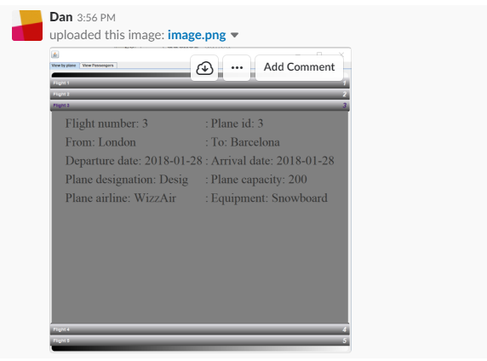

Dan [3:56 PM]

i've sort of integrated it now

i will do some prettying up later

and sort gregs bit out when it's done

Rhys Jones [3:56 PM]

Nice man

Looks good

Kris [4:53 PM]

Nice

**01/03/2018**

nice

Rhys Jones [4:41 PM]

Daily meeting, anybody got any concerns or any report of having done anything further?

I know we're waiting on your parts Greg, and Dan you need to implements greg’s part into the gui right?

Dan [4:46 PM]

Yep gonna implement it as soon as its been pushed

Also need to implement viewing seats on a flight quickly

Kris [6:00 PM]

I need to do some add methods for flight, plane and seat and also do some testing. I will try do this during the weekend.

Rhys Jones [6:01 PM]

Good stuff Kris, thanks for responding :)

Kris [6:02 PM]

Ok

**02/03/2018**

Dan [1:45 AM]

Mostly integrated Greg's stuff but datepicker is broken so need to work on that asap

**04/03/2018**

Kris [7:05 PM]

I have done add methods and testing classes . I did not create command-line forms for this methods because it will be exchanged by gui forms in future.

**05/03/2018**

Dan [9:58 AM]

Having to run to the doctor this morning so I won't be in for esa today but I can catch up with you guys tomorrow if that's alright

Sorry guys

**08/03/2018**

Rhys Jones [11:58 AM]

Krzys could you upload a copy of the database design since github reverted it back to an old one, and I cloned the repository over it since then, so lost it.

Kris [12:14 AM]

Yes

Rhys Jones [1:39 PM]

Nice one Krzys! I don’t know what happened to make it revert back to that old version! Lucky you had a copy!

Kris [1:40 PM]

Yes I got all files on pc lucky for you 😊

**11/03/2018**

Josh Roads [1:47 PM]

Before I commit (with an interface returning ArrayList<Object>) are we all gonna stick to that format for result sets? Or should I scrap the interface? Saves closing the statement after every call. Just means anything returned in the list will need a decent toString.

Ive also got an abstract that allows column names and table names to be injected into statements, so in using you'll just need to define the columns and table and the condition (if there is one). Saves massive SQL strings, but does mean there's a few extra variables. I was thinking it would work well if a dynamic search were implemented. Just means access will need to be allowed or denied in the GUI.

Dan [12:57 PM]

Yeah that all sounds great dude!

Rhys Jones [1:40 PM]

The problem with the sql being so open like that for a search is that you're making it open to the user, and not very secure, I think. We'll need an interface in front of the search, with maybe some of our own key words

Rhys Jones [1:47 PM]

But then we need to think of a way for users to know what the key words are

**14/03/2018**

Kris [4:57 PM]

I had some issues with database design. To be able to display passengers risks I had to re-design DB a bit .

Rhys Jones [4:58 PM]

What issue? It should have worked fine, and how did you re-design it?

Kris [5:00 PM]

I had added Passenger_Risk_ID as foreign key to Risk table and removed risk_ID from Passemger_risk

My cod is working lot better this way it is not big change

It is pretty same as you did in flight and seat tables btw and it is working fine.

Rhys Jones [5:08 PM]

Fair enough, I can't look at stuff now, but I don't think there was any need to change it, I know the other group used the exact same design as us for their passenger to risk relationship, and it worked fine, if it works though, then that's alright

Kris [5:13 PM]

I will show you tomorrow how it works.

**15/03/2018**

Kris [6:39 PM]

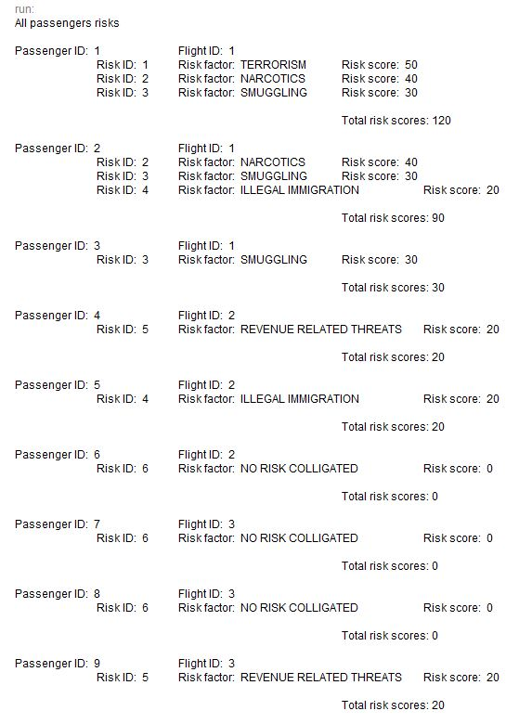

I have sort out the list view with risks , passenger ID and flights associated . If you need some more information’s to be displayed let me know.

Rhys Jones [6:43 PM]

Nice! Looks really good!

Kris [6:46 PM]

Thanks.

**18/03/2018**

Rhys Jones [10:31 PM]

Guys, i'm feeling pretty ill today, could one of you take notes on the daily meeting for me tomorrow?

**19/03/2018**

Kris [12:46 PM]

Ok ,Greg did.

Kris [5:06 PM]

I put my update for passengers risks

Code not tested yet

**20/03/2018**

Dan [3:56 PM]

Could we get a copy paste of the data being used for the risk stuff in the database?

Just so I can get it to print to console here and get a better idea of what it looks like

Kris [12:33 PM]

Its done.

**22/03/2018**

Kris [12:47 PM]

For sprint 3 I'm gonna do create new rules and risk profiles.

Rhys Jones [2:41 PM]

I'm already doing that

Kris [6:18 PM]

You should announce that on slack I was first Rhys 😊

Rhys Jones [6:24 PM]

It's in the sprint plan... For sprint 2

Under my name

Kris [6:26 PM]

Well it was not marked in product backlog . It's ok .

Rhys Jones [9:55 PM]

The marks were supposed to be removed, I was just using them to mark what had already been done when I was assigning stuff to people

Kris [9:26 AM]

Sprints supposed to show which has been done, which not has been done. Backlog should show which are assigned which not , because now is hard to say which are available.

Rhys Jones [10:31 AM]

Sprints show what has been done and what is assigned to people, the back log shows which have been done too, or at least which have been started

At least the clone I have does

I just meant the ticks that are on the names of the backlog items shouldn't be there, if you have the same copy of the sprint as me

Kris [2:32 PM]

This way how do you know which tasks been assigned and which not .Just imagine you have got 10 or 20 sprints to check for what have been done and what not .

Rhys Jones [2:35 PM]

The backlog on github, doesn't appear to be the same as the one I have

The one I have has whether the work has been done or not next to each item

Kris [2:38 PM]

Can you update GitHub one for better clarity?

Rhys Jones [3:27 PM]

Yeah, i'll do it in an hour or so :) once i'm at a pc

Kris [3:47 PM]

Thanks

**24/03/2018**

Rhys Jones [8:35 PM]

Dan i'll have the 2 things for last sprint done tonight, i'll pass them on to you, there're comments in there to explain what I was thinking of and how it would look in the gui when I made the classes

Dan [8:39 PM]

Awesome I'll get it done asap

**26/03/2018**

Rhys Jones [10:14 AM]

I'm going to finish up the rest of the product backlog today, I did my stuff for sprint2 but it will be really easy for me to add the other things in to my code, so i'm just gonna do that

Then once Dan integrates it all, we should be done

Other than the daily meetings which I still need to do, and the report. And whatever work we're still waiting on from Greg and Josh if you guys aren't finished

Oh, except for detailed searches

If somebody could do that

I don't really know what that even means so... (what kind of detailed searches it means...)

Greg [10:20 AM]

I finished and committed all of my stuff Saturday night, so I could do a few detailed searches

Rhys Jones [10:22 AM]

Alrighty, it says "more constraints" so I THINK it means searching by stuff we didn't do yet? Like searching for a flight by a passenger or finding out what seat on a flight a passenger has (which would basically be the same, since you have to find the seat in order to find the plane)

Just something simple to meet the criteria

Greg [10:23 AM]

I presume it's just the most common stuff, like searching for all flights with a certain risk number

Rhys Jones [10:24 AM]

Search for flights by risk is already one that's been done by Dan I believe

Greg [10:26 AM]

Oh right, I'll think of something, I'm sure

Rhys Jones [10:26 AM]

Aye

Dan [4:30 PM]

i've changed the riskbuilder stuff to return a passenger and a flight instead of just an ID

Kris [5:21 PM]

Ok Dan .Btw I was askig on slack do you want me to add some extra staff:)

Dan [5:22 PM]

uhh not right now because there is still a bunch to integrate and it's taking a while

unless there is something you really want to add it's cool

Kris [5:24 PM]

No, just if you want me to change my code or add some staff let me know.

Dan [5:24 PM]

okie doke will do!

Rhys Jones [8:03 PM]

I've added another field to the passenger table which is a boolean called restricted

So basically a normal admin can only view none restricted passengers

It's for the "Admin can restrict certain information" product backlog item

So basically when you view passengers you'll have to make a slight modification to check if the passenger is restricted and if they are, only add it to the list of passengers if the logged in user is authenticated

Which i've done that by making the userhandler a singleton

So you can get the instance holding the logged in user

You'll see when I commit the work

But just make a note to modify the view all / view passenger stuff

To only show restricted passengers to authenticated admins

Kris [8:09 PM]

What is the reason of making passenger restricted?

I know is gonna be special list but for what purpose?

Rhys Jones [8:11 PM]

What do you mean?

The product backlog has an item that needs to be done

Dan [8:11 PM]

Yeah that's what I was gonna ask

Rhys Jones [8:11 PM]

Saying "Admins can restrict certain information"

So authenticated Admins can make a passenger's information restricted

I.e.

Kris [8:12 PM]

I mean why they are restricted if we are thinking about scenario

Rhys Jones [8:12 PM]

If a person of importance

Is flyinf

Dan [8:12 PM]

I would think that would be more like admins deciding what passenger information is available

Instead of specific passengers

Kris [8:12 PM]

OK I see

Dan [8:12 PM]

Like making it so not everyone can view passport numbers etc

Rhys Jones [8:12 PM]

Normal people can't view those passengers details or when/where they will fly

You could do that too

But I understood it as they are able to purposefully restrict specific things

Rather than being restricted in what they can see

"Admins can restrict certain information" isn't the same as "Admins can view certain information"

Kris [8:14 PM]

All right understood:)

Dan [8:15 PM]

Yeah I was thinking that the admins can restrict information to the normal users like not allowing normal users to access stuff like passport numbers or whatever

Rhys Jones [8:15 PM]

It was just the smallest change I could think to make to hit the criteria

Ahh

I'd have thought that would just be something that would be restricted regardless

Plus it'd be kinda hard to restrict that for all normal users

Like, it's not like a field that can be turned on or off

Dan [8:16 PM]

Ah right yeah that would be a pain in the arse

**Noted Meetings log**

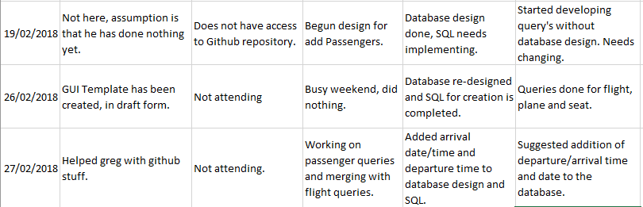

**05/03/2018**

Greg finished developing passenger queries, however needs to complete automated testing.

Krzysztof finished all his work, completing automated and integrated testing.

Rhys finished his work in week 2 of the sprint.

Dan is not present but is mostly done with his work, just needs to finish passenger GUI integration and testing.

Josh is not present and has done no work.

**12/03/2018**

Discussed some potential database issues, and solutions, resolving that nothing needs to be changed as the problems can be overcome easily through some SQL Joins

Dan started working on the new sprint tasks

Greg finished the sprint one tasks and began work on the sprint 2 tasks

Josh finished his tasks, requested more work. Shared folders task will be assigned to him

**22/03/2018**

Greg has fixed all of his merging issues and is currently developing the login system

Dan has finished the passenger search system, despite merging issues of his own

Rhys has started the system that allows users to create new rules, and is currently in the des

Many team members have reported issues with github, mainly merging issues and one incident where a design document for the Database went missing and had to be recreated